SUMMARY OF MY INTERNSHIP AT o9

Prepared by:Sibasish Padhy,intern,Data-Science,o9;
Ravi Teja Ammanabrolu,Lead-Data Scientist,o9

INDEX

SUMMARY OF MY INTERNSHIP AT o9 1
PHASE 1 3
PHASE 2 4
PHASE 3 5
SCOPE OF IMPROVEMENT 6

STAGE 1
- Recap of Data Analysis in python,traditional ml models like linear regression and logistic regression
- Learning about the fundamentals of ANN and RNN for time series Analysis
- Experimenting on WALMART dataset from m5 forecasting competition for the first phase of the project.
  - Collection of data : The Walmart sales demand dataset is taken from the popular M-5 forecasting competition hosted on Kaggle. This dataset consists of hierarchical data(data in the form of dataset)containing sales demand and prices for 3 states in the USA(California,Wisconsin,Texas). and includes item level, department, product categories, and store details. In addition, it has explanatory variables such as price, promotions, day of the week, and special events. Together, this robust dataset can be used to improve forecasting accuracy.
  - Exploratory data analysis along with XYZ Analysis(Data Segmentation and outlier handling was performed) :To know the data better to make useful insights and inferences ,the data is explored more to know about the data better. The data analysis is performed at an overall level as well for some different levels of hierarchy like at store level ,item level and sales for occasional days.
  - Implementation of the different deep learning model for multiple time series sales-demand store_item_combination data: Different deep learning models are implemented for the top 100 store_item_combinations(skus) and overall accuracies for all the models are compared with the baseline accuracy.This experiment is done to look for the model which provides better accuracy amongst the others
  - the better model with the suitable hyperparameters is selected from the sample data and implemented for all the store_item_combination_data:The model selected from experimentation is then extended for implementation for all 30490 store_item_combinations sales demand time series to forecast the sales of next 4 weeks from past 8 weeks of time series data.
  - Adding extra features to the dataset to try to improve upon the forecast accuracy along with suitable hyperparameter tuning:In an attempt to improve upon the forecast accuracy some explanatory variables like the sales on days of special events and on SNAP days are added as extra columns in addition to the sales demand data for every sku.It results in increase of accuracy by a couple of percentages.
The best model was The encoder decoder GRU model in which the learning rate was taken as 0.01-0.001 loss function as huber .The best accuracy via mape came out to be 63.2%.

STAGE 2
- A new dataset is taken as test data to pass through the model and evaluated.Here the dataset taken was hershey’s dataset and the performance is evaluated as follows.
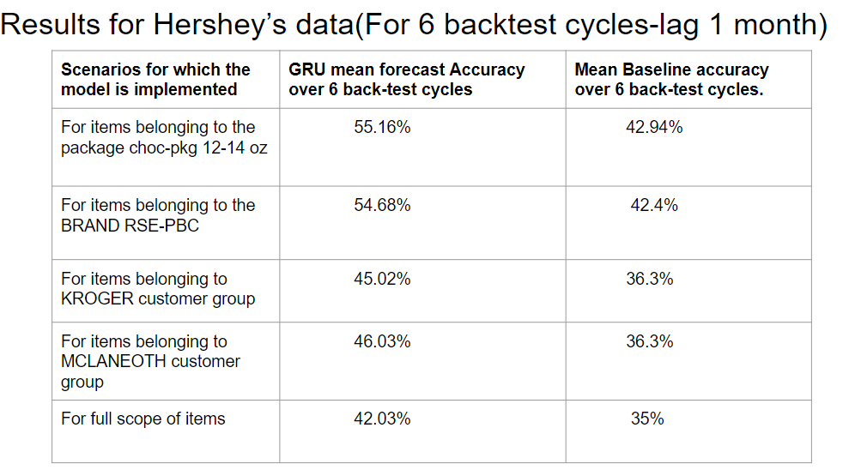

STAGE 3
- The process is then Standardized and Modularized so that it can be refined for new datasets.
- Starbucks transactional data was passed through the refined code for forecast of 13 weeks starting from 2021-11-14,
- The forecast accuracy through the GRU model came out to be 50% when compared with a baseline accuracy of 42%.
- Details about the standardization and modularization of the code is provided in another document.CODE PACKAGES FOR STANDARDIZATION AND MODULARISATION OF CODE

SCOPE OF IMPROVEMENT
- The GRU model did not perform well on highly seasonal items like the items sold in Easter for hershey’s dataset .
  - Alternative-Experimenting with time series methods like Croston for dealing with seasonal items
- A way to improve upon the current methodology so that we can add extra features(for multivariate purposes). In the current model we are not able to add SKU specific features.
- Experimenting on segment wise forecasting for all the skus(items)
- Experimentation of the GLUON TS interface on the dataset for better performance on multiple sku time series data stacked one over the other.
- Implementation of other time series methods like Vector Autoregression, SARIMA, ARIMA and comparison of performance of dl algorithms with these models.

